Summer Reading for Rising Sixth Grade Students
2020 - 2021

Summer is here! I want you to have a great summer full of fun. It is also important to keep your language skills sharp while you are away from school. This summer you will read Freak the Mighty by Rodman Philbrick. You should make a plan for completing the work at a reasonable pace so you are not rushing to get things finished at the end of the summer. Additionally, your assignment is to complete an annotated bibliography. The format for the annotated biography is attached.
You should bring your annotated bibliography and your copy of the book when you return to school. We will complete several follow-up activities together at school. Happy reading!
Sincerely,
Mrs. Goodman
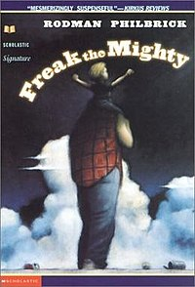

Annotated Bibliography
- Title
- Author
- Genre (nonfiction, historical fiction, fiction, fantasy, etc.)
- Publication Date (copyright date)
- Describe the setting fully in a paragraph. (time and place)
- Briefly, in five to seven sentences, summarize the plot of the book in your own words (not the words on the back of the book).
- Choose any one character and write a descriptive paragraph about that character. Some things to consider: What is he or she like? What is important to this character? What are the character’s strengths? What makes this character interesting?
- Write a one-paragraph reaction to the book. Did you love it? Did you hate it? Did you have a mixed reaction? Why? Give your opinion about whether this is a good book or not. Be sure to explain your opinion.
- Find one sentence from the book that you think is significant or important. Make sure to give the page number.
- Give one word that sums up this book.

